Sierra College Public Safety Training
Strong Workforce Program Metrics

Sierra College Fire Academy (213350)
61% Attained a Living Wage
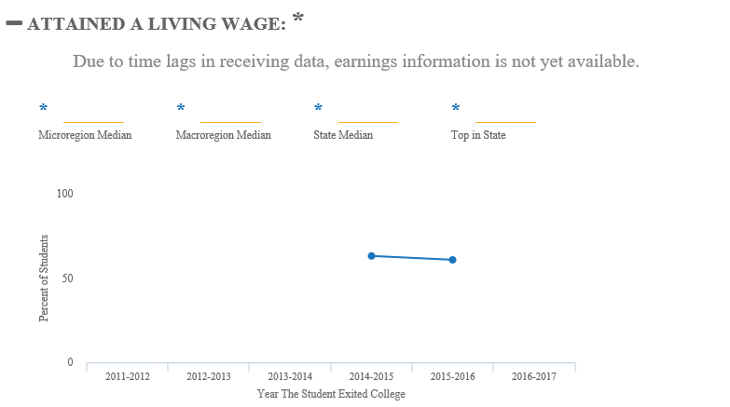
Sierra College Fire Academy (213350)
80% Employed in the Fourth Fiscal Quarter after Exit
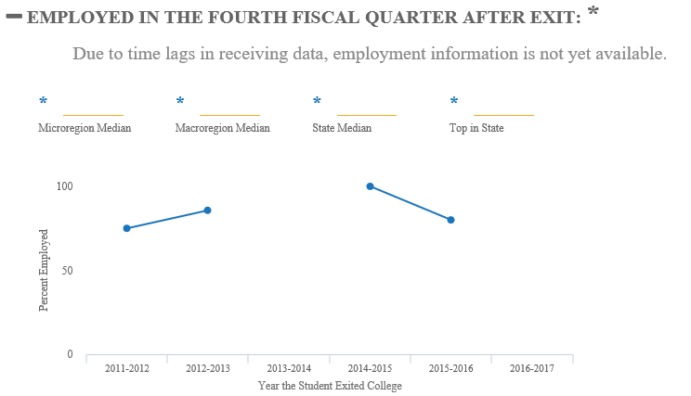

Sierra College Fire Technology (213300)
82% Attained a Living Wage
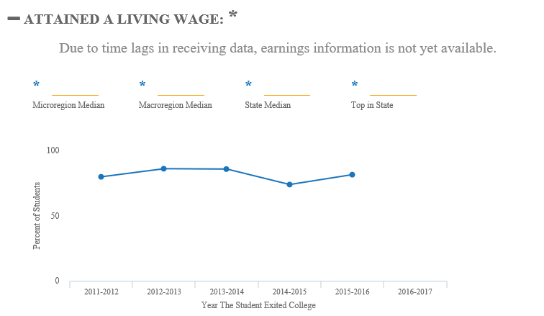

Sierra College Fire Technology (213300)
89% Employed in the Fourth Fiscal Quarter after Exit
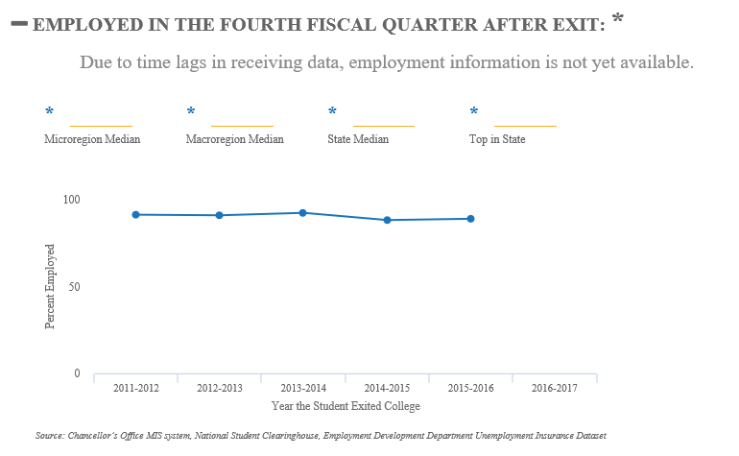

Earnings: Fire Technology (2133)
